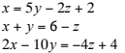
1. What is the solution to the system of linear equations?
- $(3, 2, 1)$
- $(2, 6, 4)$
- No solution
- Infinitely many solutions

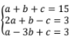

2. What is the solution to the system of linear equations?

- $a=-4, b=-9. c=20$
- $a=4, b=3. c=8$
- No Solution
- Infinitely Many Solutions

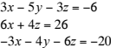

3. What is the solution to the system of equations?

- $(1,-6,-3)$
- $(1,-4,-5)$
- Infinitely many solutions
- No Solution

4. In triangle TUV, the measure of angle U is twice the measure of angle T. The measure of angle V is 80 more than that of T. Formulate the system of equations for this situation.

Equation 1:__________________________________________
Equation 2:__________________________________________
Equation 3:__________________________________________

Use the information below for the next two problems.

5. Student A spent $9 on a bottle of school glue, a package of colored pencils, and a pencil pouch. Student B spent $16 on two bottles of school glue, three packages of colored pencils, and a pencil pouch. Student C spent $17 on a bottle of school glue, two packages of colored pencils, and two pencil pouches.
Which Augmented matrix best represents the system of linear equations that could be used to solve the system?
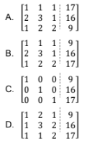

6. What price did the customers pay for a package of colored pencils?
- $1
- $3
- $5
- $9

7. A manufacturer of manila folders has three machines that, when all working, produce 592 boxes of folders per day. When only machine A and machine C are operational, they produce 352 boxes per day. Together, machine B and machine C produce 400 boxes per day.

Which system of linear equations could be used to determine the daily quantity of boxes of manila folders produced by each machine?

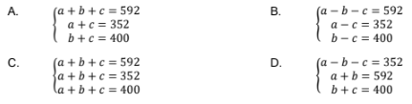

8. Asher spent $37 on four 4×6 picture frames, two 8×10 picture frames, and one 16×20 picture frame. Lucy purchased eight 4×6 frames and one 8×10 frame for $29, while Amelia spent $23 on one frame of each size.

Which system of linear equations could be used to determine the price of each type of party supply?

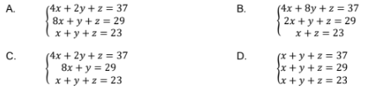

9. Which response best describes the price of each size of picture frame?

- 4$×$6 picture frames cost $5 each, 8$×$10 picture frames cost $8 each, and 16$×$20 picture frames cost $10 each.
- 4$×$6 picture frames cost $3 each, 8$×$10 picture frames cost $5 each, and 16$×$20 picture frames cost $15 each.
- 4$×$6 picture frames cost $1 each, 8$×$10 picture frames cost $11 each, and 16$×$20 picture frames cost $11 each.
- 4$×$6 picture frames cost $37 each, 8$×$10 picture frames cost $29 each, and 16$×$20 picture frames cost $23 each.

